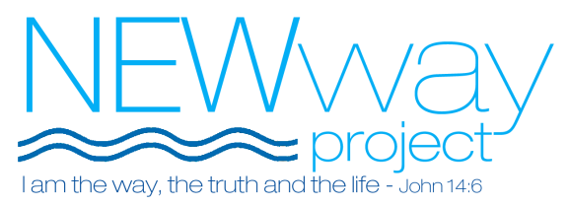

Alcohol and Controlled Drug Policy

Use of Alcohol and Drugs
State of Guests & Volunteers upon arrival
- Guests who are under the influence of alcohol or controlled drugs are not to enter the premises.
- Volunteers are not to be under the influence of alcohol or controlled drugs when arriving for their shift.
- Alcohol or controlled drugs must not be carried onto the premises by any guest or volunteer.
- If handed in by a guest on arrival the Team Leader at a NEWway venue can look after bottles or tins of alcoholic drinks for guests overnight. These will be clearly labeled with the guest’s name by the Team Leader.

Inside the shelter
- Alcohol or controlled drugs must not be consumed on the premises by any guest or volunteer.

Action to be Taken if Policy is Breached
State of Guests & Volunteers upon arrival
- If upon arrival, a guest is under the influence of alcohol or a controlled drug and deemed unmanageable they cannot enter the shelter that night and they forfeit their bed to a guest on the waiting list. They must be asked to leave but should be encouraged to see a staff member at the office the next morning.
- If guests are found drinking on the premises they are asked to leave, and such incident needs to be reported to a member of staff the next morning.
- If guests are found taking controlled drugs on the premises they will be permanently barred from NEWway and asked to leave that night.
- Anyone found dealing drugs will be permanently barred from NEWway and asked to leave immediately.

Timings of the implementation of a ban
- A Church Coordinator may decide to ban a guest from the shelter in the evening. Depending on how settled into the premises the guests in question is that night and what stage of the evening it is the Church Coordinator may however, decide to ban the guest the following morning. This is up to the Church Coordinator’s discretion, who is advised to call the Project Coordinator for advice if not present. It may be more disruptive and potentially irresponsible to remove the person from the church that night, depending on what kind of state they are in at that time and the weather conditions outside.

Suspicion of a guest using alcohol or controlled drugs at a NEWway shelter
- Volunteers who suspect that someone is violating the alcohol and controlled drugs policy must make a note of this on the reverse side of the log sheet and inform the Church Coordinator and Project Coordinator ASAP. This way volunteers the following night can be made aware of the situation. Such observations will be taken into account when warnings or bans are being issued by staff.
- Volunteers should police their shelter. All those involved in NEWway are to be gracious, loving and compassionate seeking to build trust and friendship with each guest. However, at the same time it would be a disservice to our guests, fellow volunteers and the host church if we are negligent. Furthermore, negligence always leads to problems and shows a lack of organisation and real care for the guests.

Communication of NEWway Alcohol and Controlled Drugs Guidelines to Guests and Volunteers
- Guests will be clearly advised of the Alcohol & Controlled Drugs Policy by the Project Coordinator before entering the shelter. This policy is contained within the wording of the NEWway Guest Agreement that all guests have to sign as a condition of accessing the project. Guests will be given a copy of this policy in their welcome pack.
- New volunteers should be informed of the Alcohol and controlled drugs policy at briefing meetings before the shelter opens that night.
- If anyone is excluded from NEWway as a result of breaching the policy all Church Coordinators will be informed by e-mail or at briefings at your venue at the start of a shift. The Project Coordinator will do this. In particular the church responsible for the following night must be informed with immediate effect.

